**Experiment No. 9**

**DIV: A** **Batch: A4**

**Team Members:**

**Name: SAP ID:**Dhruvi Jodhawat 60004190032

Harvy Gandhi 60004190043

Junaid Girkar 60004190057

**Aim:** Study of Configuration Management using GitHub

**Theory:**

Git is a distributed revision control and source code management system with an emphasis on speed. Git was initially designed and developed by Linus Torvalds for Linux kernel development. Git is a free software distributed under the terms of the GNU General Public License version 2.

Git Life Cycle

General workflow is as follows −

1. Clone the Git repository as a working copy.
2. Modify the working copy by adding/editing files.
3. If necessary, update the working copy by taking other developer's changes.
4. Review the changes before commit.
5. Commit changes. If everything is fine, then push the changes to the repository.
6. After committing, if something is wrong, then correct the last commit and push the changes to the repository.

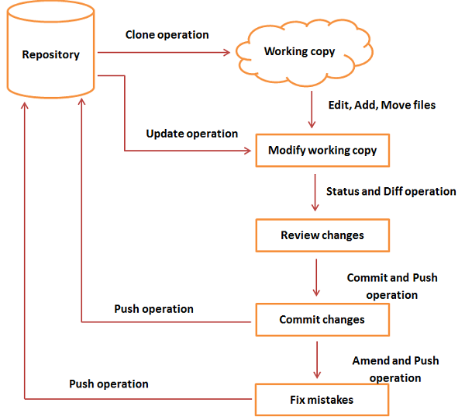

Git Life Cycle

**Git Commands:**

| **pwd mkdir ls** |
| --- |

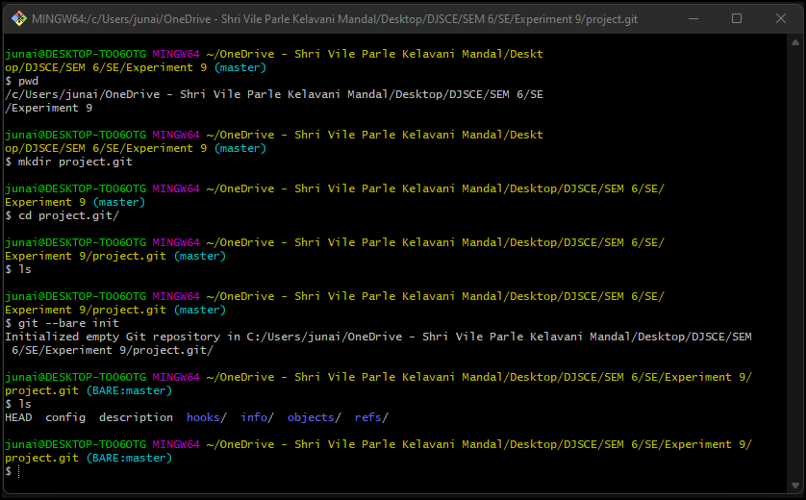

| ssh-keygen |
| --- |

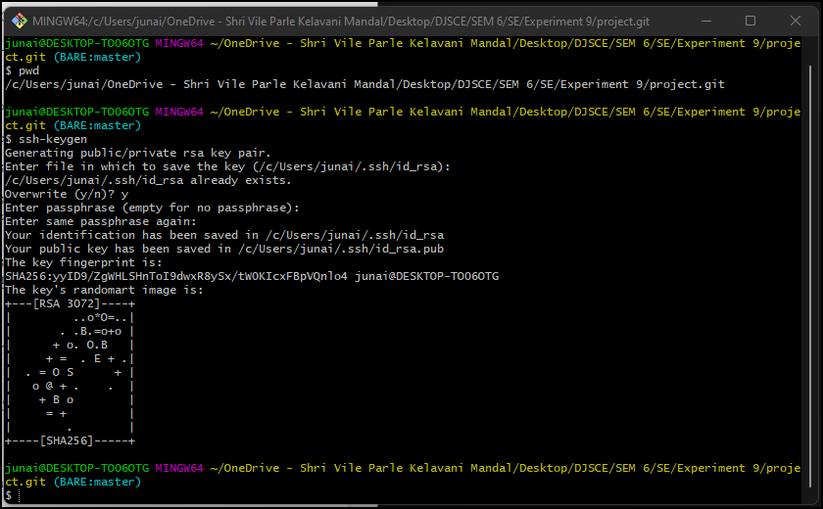

| git init git status |
| --- |

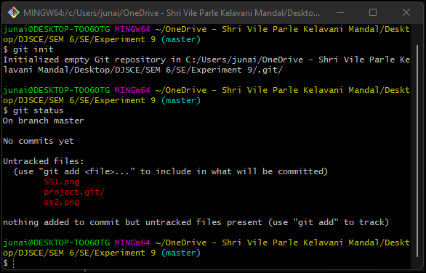

| git add . |
| --- |

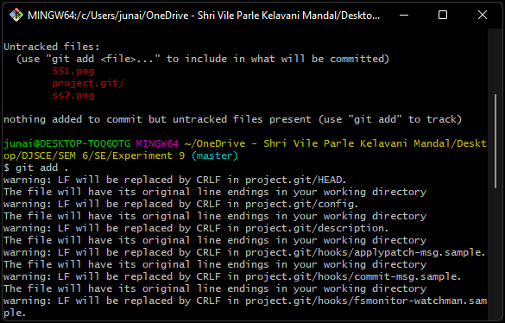

| git status |
| --- |

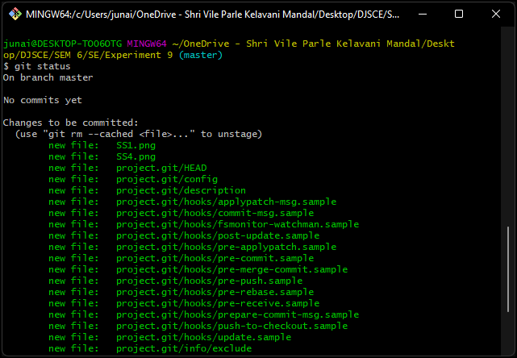

| git commit |
| --- |

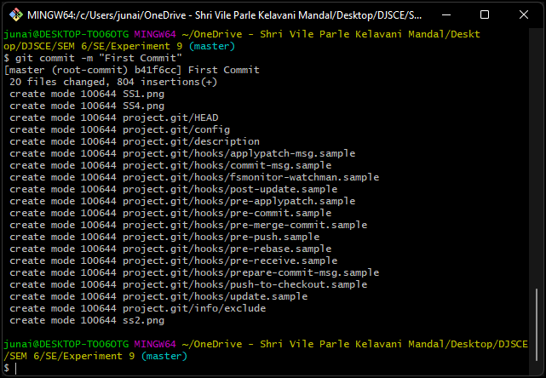

| git remote add origin git branch -M master git push -u origin master |
| --- |

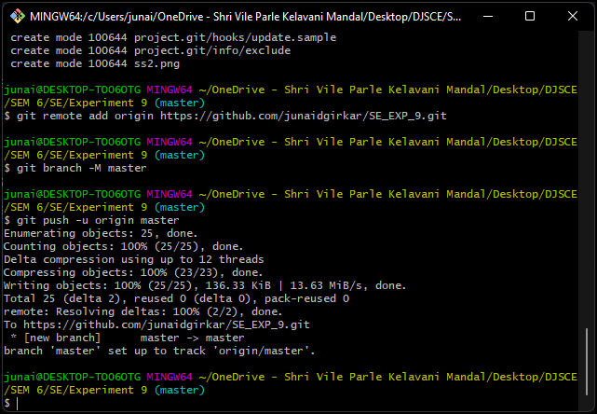

| git add . git stash git pull |
| --- |

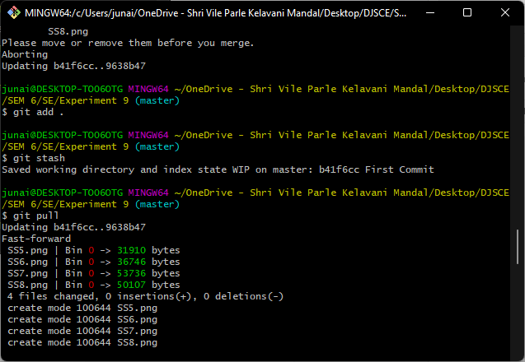

| git log git log -all -oneline -decorate -graph |
| --- |

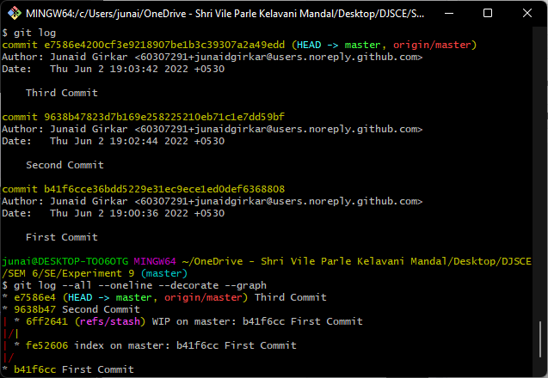

**CONCLUSION:**

Git is a version control software that can store different versions of files on a local machine or can be integrated with remote file management systems such as Github and BitBucket. In this experiment, we used the git bash CLI to run some of the git commands and linked it to Github.